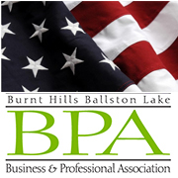
Burnt Hills-Ballston Lake Community Flag Day Parade

Sponsorship Form

NAME__________________________________________________________________________________

ADDRESS________________________________________________________________________________

PHONE______________________________ EMAIL___________________________________________

CONTACT NAME__________________________________________________________________________

Please indicate your selection(s) of support by marking the appropriate area(s) below:
SPONSORSHIPS

Old Glory Sponsor $2,500 ** Inclusion in press releases will be made
after receipt of payment.
Red, White, & Blue Sponsor $1,000

Stars & Stripes Sponsor $400

Spirit of ’76 Sponsor $250

Minuteman Sponsor $100

**Ad Copy is due by 5/17/24 and can be e-mailed to: bhblparade@gmail.com

Please check this box to use last year’s ad.

**Please be sure to provide your email address above so we may email you information for new ad copy.
Payment should be made payable to the “BH-BL BPA” and mailed to the address below or submitted online through our website www.bhblbpa.com.

BH-BL Business & Professional Association
PO Box 1043
Ballston Lake, NY 12019

