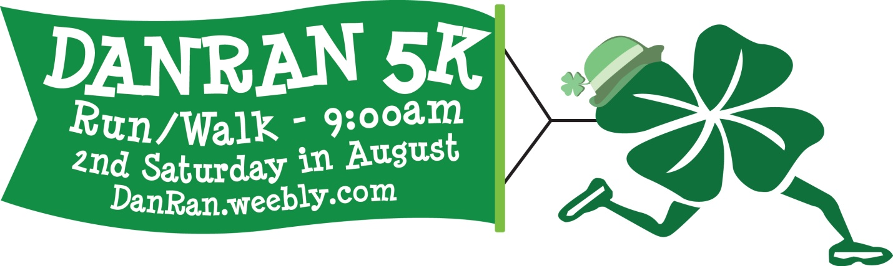

Dear Fellow Supporter,

A dear friend of the Burnt Hills -Ballston Lake community, Daniel G. Ward, passed away suddenly on May 3rd, 2009. Danny had worked at Carney’s Restaurant for 27 years and in addition to being a model of professional hospitality, was a friend to many. He was always there for his family and friends and we would like to continue to honor him and show how much he was respected and appreciated in our community.

Our goal is to perpetuate the memorial fund established in honor of Danny (BH-BL ’72) to recognize his commitment and love for the Burnt Hills-Ballston Lake Community. To this end, we have established a scholarships fund for High School seniors who are pursuing a career in the hospitality field. We are looking to extend our reach and the dedicated sponsorships and participants continue to grow!

Accordingly, we have organized the 6th Annual DanRan 5K Run/Walk Race on a course that starts and finishes at Stevens Elementary School in Ballston Lake on August 13, 2016 at 9:00 AM. All proceeds will benefit the Danny G. Ward Memorial Scholarship Fund.

To make this community event a success and to achieve this goal, we are appealing to area business leaders like you in hopes that you would be able to sponsor our event. There are several sponsor level opportunities per the attached form. Please note that The Daniel Ward Memorial Fund is a tax-exempt 501 (c)(3) organization.

If you would like to sponsor 6th Annual DanRan5K Run/Walk, please review our sponsorship levels below and join the team for educational excellence! A minimum sponsorship of $250 would be greatly appreciated, so please consider supporting this worthwhile community fitness run. Thank you for your interest in this worthwhile community event honoring our brother, uncle and friend Danny and your help to celebrate Danny’s legacy in such a wonderful way.

The Family and Friends of
Daniel G. “Danny” Ward

Daniel Ward Memorial Fund

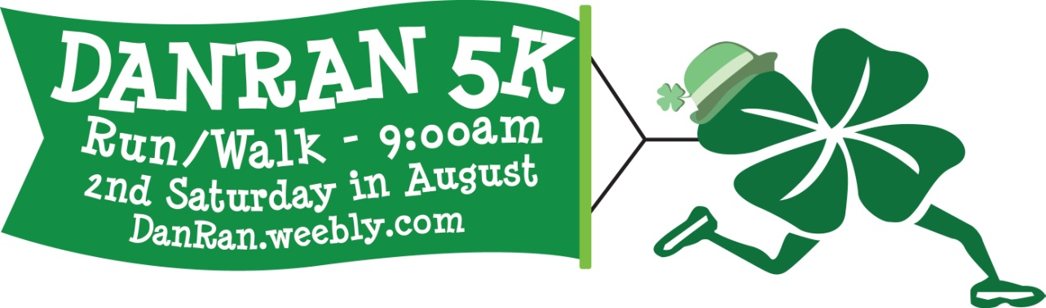
SPONSORSHIP OPTIONS

Hospitality Sponsor - $2,500
- Live Link Logo featured on our web site Home Page and Sponsor Page!
- Promotional mention with web link on our Facebook and Twitter Pages.
- Race Day banner, Event Signage and special mention at our event.
- Premier positioning of Company logo on our race T-shirt.
- Recognition in media events and press releases as a Sponsor.
- 12 Free Race Entries (Individual or up to 3 teams of 4).

Culinary Sponsor - $1,500
- Live Link Logo featured on our web site Sponsor Page!
- Promotional mention with web link on our Facebook and Twitter Pages.
- Race Day sign and special mention at our event.
- Priority positioning of Company Name/Logo on our race T-shirt.
- Recognition in media events and press releases as a Sponsor.
- 8 Free Race Entries (Individual or up to 2 teams of 4).

Racino Sponsor - $1,000
- Company Logo featured on our event web site Sponsor page.
- Promotional mention with web link on our Facebook and Twitter Pages.
- Race Day sign and special mention at our event.
- Company Logo on our race T-shirt.
- 4 Free Race Entries (Individual or 1 team of 4).

Bistro Sponsor - $500
- Company Logo feature on our event web site Sponsor page.
- Promotional mention on our Facebook Page.
- Race Day sign and special mention at our event.
- Company logo on our race T-shirt.
- 2 Free Race Entries.

Tavern Sponsor - $250
- Company Logo feature on our event web site Sponsor page.
- Race Day sign at our event.
- Company logo on our race T-shirt.

Bartender Sponsor – $100
- Company Logo on our race T-shirt.

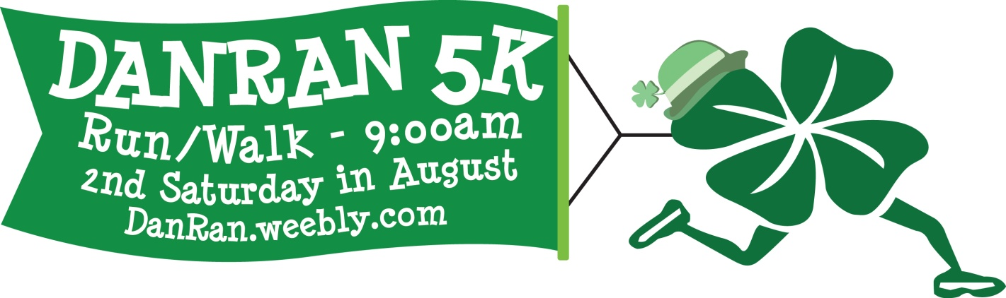
SPONSORSHIP SELECTION

Hospitality Sponsor - $2,500

Culinary Sponsor - $1,500

Racino Sponsor - $1,000

Bistro Sponsor - $500

Tavern Sponsor - $250

Bartender Sponsor – $100

Company Name:
Address:
City:
State: Zip:
Phone:
Email:
Authorized Signature:
Please provide a photo quality logo (jpeg and eps) for web and t-shirt printing on or before 07.23.16.
Checks Payable to: The Daniel Ward Memorial Fund
c/o Sarah Best
12 Hollywood Drive
Burnt Hills, New York 12027

You can also contact the Race Director, Michael Hale at 518.399.4846

